# **Group Testing Report**



|  |
| --- |
| **Group:** C1.031 |
| **Repository:** https://github.com/aaronma300604/DP2-C01-31 |
| **Members:**  **Student #1:** López Ramos, Daniel ([danlopram@alum.us.es](mailto:danlopram@alum.us.es))  **Student #2:** Ángel Postigo, Estrella ([estangpos@alum.us.es](mailto:estangpos@alum.us.es))  **Student #3:** Miranda Balastegui, Iván ([ivamirbal@alum.us.es](mailto:ivamirbal@alum.us.es))  **Student #4:** Terrón Hernández, Diego ([dieterher@alum.us.es](mailto:dieterher@alum.us.es))  **Student #5:** Mayoral Ansias, Aarón ([aarmayans@alum.us.es](mailto:aarmayans@alum.us.es)) |
| **Date:** Seville May 25, 2025 |

Table of Contents

**Testing Report** 1

**Revision Table** 3

**Introduction** 3

**Contents** 3

**Functional Testing** 3

**Performance Testing** 5

**Conclusion** 10

**Bibliography** 10

# **Revision Table**

|  |  |  |
| --- | --- | --- |
| **Revision Number** | **Date** | **Description** |
| 1.0 | 25/05/2025 | Intial version – all sections added |

# **Introduction**

The purpose of this document is to provide an analysis of the various tests that have been carried out to assess code coverage related to the group requirements, as well as an analysis of the system's performance with respect to the requirements associated with that student.

# **Contents**

## **Functional Testing**

The following is a list of functional tests performed for the entity Airport:

* List-show-a.safe: This test checks the functionality of listing the airports and showing the specific content of all the entities.
* Create-a.safe: Several airports are created using valid test data accepted by the system. An attempt is made to create an airport without providing any information (returning the corresponding error messages), and finally, some valid data is added along with various invalid values.
* Update-a.safe: The same validation tests as in the previous file are carried out for the update service instead.
* Url-a.hack: Hacking attempts are performed on all services by conducting tests using invalid IDs in the URL, empty fields, unauthorised requests, etc.

The test coverage achieved for the entity Airport is 99.6%.

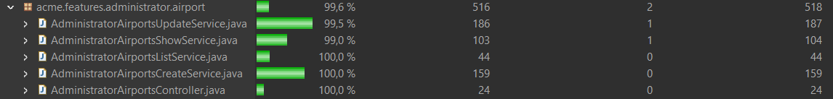

## 

## **Performance Testing**

A performance analysis of the system will now be carried out through the execution of the previously mentioned functional tests. The tests have been executed under two different scenarios:

* Without indexes for query optimization: The Excel file “tester-performance-clean-no-index.xlsx” contains the average performance results of the test operations as illustrated in the following chart.

As observed, the most time-consuming operation on average is the creation of airports, which takes more than 20 milliseconds.

Below are some statistics regarding the operations:

As we can observe, the system without indexes gives a confidence interval ranging from 7,54 milliseconds to 11,18 milliseconds.

* With indexes for query optimization: The Excel file “tester-performance-clean-index.xlsx” contains the average performance results of the test operations, as illustrated in the following chart.

As we can see, the most time consuming operation on average is still the airport creation, which takes now takes exactly 20 milliseconds. All operations have decreased their response time compared to the previous analysis. However, there doesn't appear to be a significant change in their performance.

Below are some statistics regarding the operations:

As we can observe, the system with indexes gives a confidence interval ranging from 7.5 milliseconds to 11.03 milliseconds.

Next, using both confidence intervals, a hypothesis test will be conducted using a z-test. This test is documented in the file “z-test.xlsx”:

The pvalue obtained from the z-test is 0,965115882. This value is greater than alpha, which in this case is 0.05. We can conclude that the changes are not significant enough in terms of system performance.

# **Conclusion**

99.6% of the code related to Airport has been tested, enabling the detection and correction of bugs that were not initially apparent. Additionally, it has been statistically demonstrated that the requirements implemented meet the non-functional requirement that the system, on average, takes less than one second to perform operations on the entity, improving the user experience when interacting with the system.

# **Bibliography**

Intentionally blank